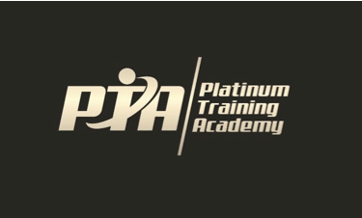
Release of Liability
I (or I on behalf of my child) on behalf of myself, hereby irrevocably waive, release and fully discharge Platinum Training Academy PTY LTD, their respective officers, directors, employees, agents, and shareholders, of and from any and all rights, claims, demands, expenses, costs, lawsuits, and causes of action (including, but not limited to, consequential damages) due to or arising from any accident, injury, damage or loss directly, indirectly or in any way associated with my participation of myself (or any participating child of mine under the age of 18 years) in the Powerlifting competition held at Platinum Training Academy sponsored by Platinum Training Academy PTY LTD.
I represent that I know of no medical reason or condition that would impair my ability (or my child's ability) to participate in this event, and I hereby assume any and all risk of accidental, medical injury or consequential damages resulting to me from my participation (or resulting to my child from his/her participation). I acknowledge, understand and accept the inherent risks of Powerlifting competition.
By signing this release from liability, I irrevocably waive all rights, claims, demands, lawsuits and causes of action against everyone connected with this contest.
I have read the above release, understand its meaning and consequences, and intend to be legally bound by its terms and have signed this release freely and voluntarily. If signing on behalf of a child under the age of 18, I acknowledge that I as the legal guardian of such child and able to provide, on their behalf, the waivers and releases contained in this document.
_________________________________________________________
Signature (in full) of applicant Date
_________________________________________________________
Print name of applicant
_________________________________________________________
Signature (in full) of parent or guardian if applicant Date is under 18 years of age.
_________________________________________________________
Print name of applicant under 21 years of age

